This workbook is adapted from the Government of British Columbia, Investment Agriculture Foundation of BC, and their contributors.

Saddle Hills County and their council, employees, or contractors will not be liable for any claims, damages, or losses of any kind whatsoever arising out of the use of, or reliance upon, this information.

Guide to AGRICULTURAL PRODUCER WILDFIRE PLAN WORKBOOK

Guide to completing an Agricultural Producer Wildfire Plan
Alberta

Contents
Overview 1
Title Page and Header 2
Part A: Before a Wildfire 3
1. Wildfire Threat 3
2. Agriculture Operation Information 3
3. Grazing Lease Information 4
4. Emergency Contacts 5
5. Agriculture Operation Maps 7
6. Livestock Inventory 13
7. Livestock Location(s) 14
8. Vehicles and Response Equipment / Resources 14
9. Water Sources 15
10. Risk Reduction – On Property 15
11. Risk Reduction – Range Level Assets 18
12. Insurance Information 19
13. Backup Power 21
Part B: During a Wildfire 22
14. Information Sources 22
15. Decision Guide for Livestock Protection 23
16. Checklist for Sheltering Livestock in Barn 24
17. Checklist for Moving Livestock to On-Site, Outdoor Location 24
18. Checklist for Relocating Livestock 25
19. Checklist for Opening Gates, Cutting Fences to Free Animals 26
20. Checklist to Create a Fire Break 27
21. Checklist to Deploy Sprinklers 27
22. Checklist for Operating Backup Generator 28
23. Checklist for Personal Evacuation 28
24. Checklist for Visitor and Employee Evacuation 29
Part C: After a Wildfire 32
25. Checklist for Damage Assessment 32
26. Checklist for Initiating Insurance or Other Loss Coverage 32
27. Checklist for Recovery 35
Part D: When Wildfire Plan is Complete 36
Part E: Additional Resources 37

Guide to Completing an Agricultural Producer Wildfire Plan

Overview
Creating an Agricultural Producer Wildfire Plan, or Wildfire Plan, is an essential step in preparing for a major wildfire event. A Wildfire Plan focuses on actions producers can take before, during, and after a wildfire to protect their operations and businesses.

An agriculture-specific Wildfire Plan could help you in many ways. Specifically, a Wildfire Plan:

- Helps producers make decisions now, while there is time to calmly consider options and collect specific information that may be difficult to obtain in a crisis.
- Informs family members, staff, neighbors, and first responders how they can help during a wildfire emergency.
- Helps producers intending to return to the agriculture operation during or after an evacuation order.
- Reduces harm to agricultural operations, assets, crops, and livestock.
- Demonstrates “due diligence” when negotiating with insurance providers.

By using this Guide and the Workbook to complete a Wildfire Plan, producers are taking steps to protect themselves and to prepare for wildfire events where they may require assistance. This Guide and Workbook are suitable for use by all producer types, from livestock to mixed agriculture operations, horticulture and field crops. The Workbook also includes considerations for operations that have commercial production systems on-site and receive significant numbers of visitors to their facilities during wildfire season (agriculture operation gate sales, u-pick operations). Some content and sections are commodity-specific and should only be completed if applicable. All sections are included in one comprehensive Workbook for the benefit of producers who engage in more than one type of agricultural production.

The Guide and the Workbook work together to focus on the critical decisions and actions that should be addressed before a wildfire occurs. This Guide refers to specific parts of the Workbook.

Each recommended action is identified by a check box (□) in both the Guide and the Workbook. Place a check mark in the box as you complete each task. Once you have completed your Workbook it will become your Wildfire Plan. Retain this Guide to periodically update your Wildfire Plan.

The Workbook is available in both fillable PDF and Microsoft Word format, allowing producers to create a Wildfire Plan by filling in their specific information. Producers can then edit and print their own plans and update them regularly. Some customizations may be required to meet individual producer needs and circumstances. For example, producers who manage multiple properties under different ownership or who own multiple parcels under varying management may wish to include a

summary of key information collated for all properties. Some producers may wish to incorporate more visuals or provide translation of critical information to address language barriers and make the Plan accessible to all personnel.

Note: If you complete the fillable PDF document, this information will auto-populate the Wildfire Plan Summary.

Key information from your completed Wildfire Plan may be used as a Wildfire Plan Summary, provided in Appendix A of the Workbook, for summarizing relevant information. This Wildfire Plan Summary may be used to initiate dialogue with key agencies (e.g. municipalities, fire departments, AB Wildfire Service) in advance of the wildfire season, and may assist to support identification and protection of your operation.

Some producers may want to adapt this Wildfire Plan Summary for their own purposes and for different end-users, such as employees, managers, owners, family, and neighbours.
Key Messages
A completed Wildfire Plan is the best way to mitigate and prepare
for a wildfire event on or near the agriculture operation.

Producers are ultimately responsible for protecting their operations through planning and mitigation and, as applicable, must consider employees, visitors, and animals/livestock in planning for emergencies.
Government financial assistance only covers losses that are not
commercially insurable.

Title Page and Header
Begin preparing a Wildfire Plan by adapting the Title Page contained in the Workbook to your specific circumstances. The Title Page should identify your agriculture operation. The agriculture operation name should also be added to the Header, so it appears at the top of each page.
Consider the following steps:
- Include the agriculture operation name in the title on the Title Page, replacing the
Underline.
- Add the date the plan was completed or updated to the bottom of the Title Page.
- Add the agriculture operation name to the header at the top of Page 1 in the
Workbook.

Part A: Before a Wildfire

Wildfire Threat
It is important to understand the wildfire threat to agricultural operations. Some regions of the province experience wildfires on a regular basis and, depending on the location of your operation, there may be specific considerations regarding the types of risks (e.g. fuel types, interface risks etc.). The wildland urban interface is defined as the area, or zone, where structures and other human development meet or intermingle with undeveloped wildland or vegetative fuels.

To learn more about wildfire hazards in the area, consider these actions:

 | 1. | Review the Alberta Wildfire website for information on fire danger forecasts, restrictions and bans, as well as information for agricultural operations to prepare for all hazards, including wildfire.  www.alberta.ca/alberta-wildfire
 | 2. | Talk with your neighbors about wildfire events that have occurred in the area in the  past. Knowing the local history is a good starting point.
 | 3. | Stay current on Alberta’s wildfire situation, including wildfires of note.  www.alberta.ca/wildfire-status  Download the Alberta Wildfire app to stay current while you’re on the go.

Agriculture Operation Information
Basic information about the agriculture operation helps outside organizations provide the assistance that may be needed during a wildfire. Part A of the Workbook offers a simple table that can be used to record essential information about the agriculture operation and the people associated with it.

Ensure details are recorded accurately and printed clearly. Producers may later want to share this information via email or fax, or providing a [photo]copy during a wildfire emergency.

The above information may also be requested by the municipal government to assist with a permitting system to allow producers access to an evacuation zone (subject to risk - in order to perform livestock and crop management services essential to their operations). Depending on the re-entry permitting protocols in place, if any, during an evacuation order, the licence plate and driver’s licence numbers of the operation manager and staff may also assist in the administration and identification of permittees.

A Legal Subdivision (LSD) is a number that uniquely identifies a parcel in the land title registry of Alberta. The LSD can be found on the tax assessment notice. This number could be helpful for responders to locate or reference an agriculture operation.

A taxation roll number is a number assigned to a property by the municipality in which it is located. In the event of a wildfire emergency, it is an important property identifier linking your property information to local government mapping. It can potentially be used by regional districts to identify your property in relation to a specific wildfire event and inform emergency operations, and may also potentially link to your essential Wildfire Plan information if provided to the regional district in advance of the wildfire season.

Consider the following steps:
❑
❑

1. Record the essential information about the agriculture operation in Part A,
Agriculture Operation Information.
2. Take photographs and/or video of important assets to document their existence and condition, noting the time and date the images were collected. For insurance purposes, it is important to photo-document annually from the same location/position.
3. Store essential operation records and images in a fire-resistant filing cabinet or at an
off-site location. Consider backing up electronic files using cloud storage services in Canada.

Grazing Lease Information

[Skip to Section 4 if you do not have livestock on your property]
For agricultural producers with a grazing lease, record the Grazing Lease Number (GRL, inclusive of range use and grazing permits) and location of the lease(s) in relation to your main operation. The GRL number is a unique identifier for a Lease Agreement (e.g., GRL000000). Multiple areas belonging to the same Lease Agreement may have the same GRL Number with unique block IDs.

For some producers, the lease will be located adjacent to their main operation (i.e., cattle may be ranged from the farm gate); for others, the lease will be located a distance that requires livestock to be hauled between the lease and the main operation.

Emergency Contacts
An important step in preparedness is identifying people and organizations that can assist when needed. Creating a list now saves time during an emergency and allows a producer to quickly engage others in responding to a wildfire that threatens their agriculture operation.

Understanding the roles and responsibilities of emergency management and wildfire response agencies is key to determining which support resources to contact when, and for what information, before, during, and after wildfire:
  - Local Municipal Government – The local authority is responsible for the Emergency Operations Centre (EOC), issuing evacuation alerts, control of evacuation zones, and establishing protocols around temporary re-entry. They will be the key contact for information, notifications, and updates regarding threats and emergency status. They may be contacted in advance of the wildfire season to provide information on local water supply, evacuation routes, and may provide maps to assist you in pre-planning. You are encouraged to share relevant information from your completed Wildfire Plan Summary
(See Appendix A of the Workbook) with the local authority prior to wildfire season as it may be used to support emergency operations and response planning during a wildfire event. During an evacuation alert, they may be contacted regarding evacuation concerns and guidance specific to your operation. During an emergency, and particularly during an evacuation order, their focus is on public safety; however, they may engage agriculture specialists and provide logistical support to producers for livestock relocation. The local government also provides support in administration of disaster financial support during, and after, a disaster.
  - Alberta Agriculture – Agriculture resource specialists assist the EOC or Provincial Emergency Coordination Centre (PECC) by invitation. Municipalities can reach out to Alberta Agriculture’s Emergency Management department for information on preparing for and responding to hazards such as wildfires.
  - Environment and Protected Areas – Municipalities can reach out to the Alberta Parks Public Lands Manager regarding the possibility of accessing crown grazing land during a wildfire, pending feed and water availability.
  - Animal Rescue Organizations – Municipalities can reach out to Animal Rescue Organizations regarding the possibility of their support during an evacuation.

Although mobile devices can carry important contact information, they may not always be available. A printed, and laminated, list of emergency contacts ensures ready access and allows others to assist in responding to a wildfire emergency. The Workbook suggests some common emergency contacts, although it is also recommended to include any additional contacts.

Take these steps to include emergency contacts in the Wildfire Plan.
1. Use Part A, Section 4. Emergency Contacts in the Wildfire Plan to prepare a list of emergency contacts for the operation. Include the licence plates and driver’s licences of management and staff to help facilitate passage at control points in the event of permitted entry during an evacuation order. This is subject to regional district permitting system used, if any. It is critical to provide a local manager/contact that can be available, and be onsite if necessary, during an emergency.

If water is purveyed to your property (i.e. you are not well-based) record the business name of the water purveyor or water authority (e.g., Irrigation District name or local government system), and an emergency contact.
2. Meet with your neighbours, local community groups, farmer institutes, and agriculture associations each year, to discuss available resources, equipment, and space (for relocated livestock). Arrange text messaging, phone tree or other communication systems among producers so that you can help each other quickly in a wildfire emergency.
3. Conduct an annual check-in with each person or organization on the Emergency Contacts list to confirm the contact information is current.
4. Make several copies of the Emergency Contacts list and keep them in different locations, including a personal vehicle. Add key contacts to mobile phones.
5. If you are not currently a member of an agricultural association, become familiar with the organizations that may be able to provide support or act as communication liaisons during a wildfire event.

For small operators or hobby producers with livestock and/or domestic animals, this may include animal rescue organizations, such as Alberta SPCA, In the Woods Animal Rescue, or local shelters in your area.
A comprehensive list of provincial livestock-specific agriculture association contacts is provided on page 5 of the Workbook.
.

Agriculture Operation Maps
Maps are essential for preparing for, responding to, and recovering from wildfire emergencies. Maps are also very useful for engaging agencies, such as the local fire department, utility response teams, or the Alberta Wildfire Service.

Some producers may wish to sketch a simple map using graph paper. Paper maps may also be obtained from your local government office, such as the Municipal District or County office.

You can also create a map of your operation using municipal district or County web map services. These Geographic Information System (GIS) mapping functions can display a property and save a screenshot of the image to provide a base map. Visit your local regional district website (or contact your County office) to see what map services are available:
Recreational Access to Agricultural Public Land offers property data, including basic maps. Producers can search for their properties by address at:
geospatial.alberta.ca/gcx_recaccess/Viewer/?Viewer=gcx_recaccess

Readily available resources, like Google Earth (a free, downloadable program) allow producers to zoom in to every section of an agriculture operation, and to tag, label, and draw a boundary around a piece of property. To download Google Earth, see:
www.google.com/earth/

A range tenure holder may use their most current Range Use Plan map as a source for
range- level Wildfire Plan mapping.

Actions for preparing a map (or multiple maps) for the Wildfire Plan include the following.
Note: Several map features listed below are described in greater detail in the subsequent sections of the Guide.
❑

- Obtain or create a base map of the agriculture operation, showing at least the following elements:
  - Property boundaries.
  - Access roads, including local and unclassified roads, and evacuation routes off the agriculture operation site. Ideally multiple routes off and away.
  - Surface water, including ponds and streams.
  - Hydro lines.
There may be value in creating one small scale map (larger geographic extent) to show the adjacent properties and access routes, as well as all property lines. A second, or several, large-scale map(s) (smaller geographic extent) may show details that are important to helping others protect your property and operations.

For grazing lease holders, consider creating another smaller scale map to show the layout of your operations and lease (home, lease, and pasture), that includes roads and access points.
For producers with multiple operations and/or parcels of land, another smaller scale map will add value, showing the layout of your satellite operations/parcels. Include roads and access points. For example, identify separate parcels under the same company that may be managed or operated by different family members or employees.
For agri-tourism operations and operations with visitors and/or employees at risk during wildfire season, create a separate evacuation plan map for use by you and your employees, and for posting at your site, as necessary.
Consider using the grid provided in the Workbook to sketch an outline of the property and key elements.
- Add important operation and site features and, as applicable, range tenure features, to the map, and label each item.

Include features and assets that you want to identify for outside suppression agencies; for protection from wildfire as well as for protection from the impacts of suppression activities, such as machine fire guard construction.

Important operation and site features include:
  - Fences.
  - Gates and cattleguards.
  - Structures, including main house, barns, sheds, produce/inventory storage, sorting, packing, grading, processing buildings, farm market, on-site sales/retail, tasting facilities, restaurant, and other specialty buildings.
  - Public parking and access areas.
  - Pastures, corrals.
  - Wells, tanks and pumps, standpipes, private water reservoirs, including water hook-up locations for pump/sprinkler system.
  - In-ground and above-ground irrigation systems, identified as gravity fed or powered.
  - Water lines.
  - Gas lines.
  - Surface water that is suitable for fire suppression.
  - Public reservoirs and other water sources available.
  - Perennial crop production infrastructure (e.g. irrigation systems, trellis systems).
  - Access points to adjacent Crown Land.
  - Hazardous areas on the property, such as manure holding ponds and pesticide, fuel, and chemical storage locations.

3. Identify structures to receive priority protection and rank their relative priority using either a color coding or numbering system, from highest to lowest priority for protection (e.g., red=high, yellow=moderate and green=low priority or #1 highest to #3 lowest priority). Clearly indicate the ranking in the legend.
- Show on the map the equipment and locations that could be useful in a wildfire, including:
  - Fire extinguishers.
  - First aid kits.
  - Sprinkler kits and setup locations.
  - Generators.
  - Animal loading areas.
  - Structures that may be used for sheltering livestock.
  - Tractor and plow implements, front-end loaders, excavators.
  - Hazard-reduced areas (i.e. cleared land), safe places to shelter livestock.
5. Include a legend to define any symbols on the map and any priority ranking system used, as applicable. Add a north arrow and a map scale.
6. Make several copies of all maps and include one in the Wildfire Plan in Section 5,
Agriculture Operation Maps.

Sample Map: Agriculture Operation
❑
□

Road
Garden

AB Hydro Line
Vehicle Access

XYZ FARM

Chicken Run

House
Sheep Sheds
Coop
- First Aid

Well and Pump Connected to Sprinklers
Main Barn
- First Aid
- Fire Ext
- Fixed Generator

Shed
❑
❑
- Generator
- Emergency Equipment
- Pesticides

Pond
OK to use for fire fighting

Legend Structure Driveway
Fence Gate
Property Line

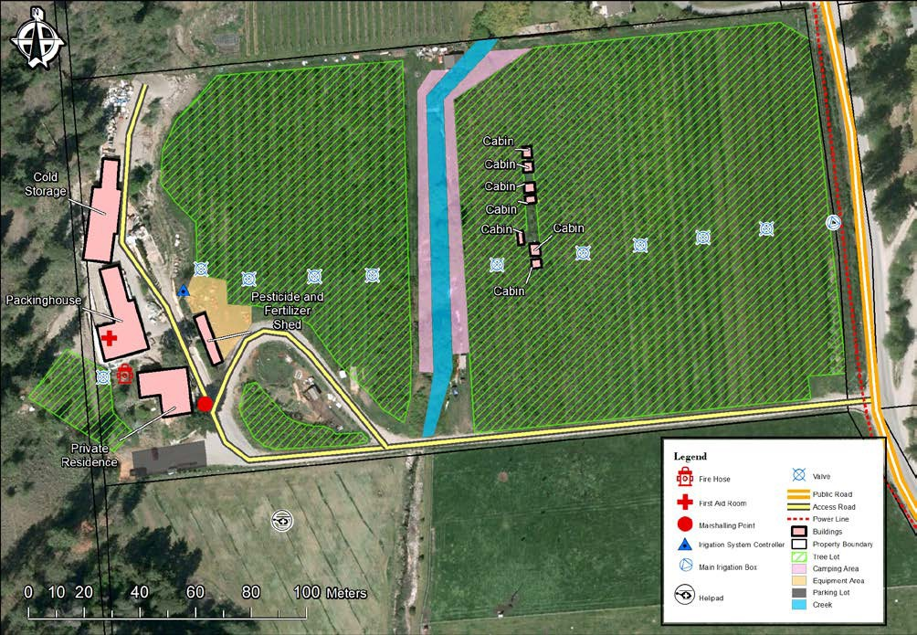
Sample Map: Tree Operation

Sample Map: Range Level Basemap

A Range Level Basemap shows the layout of your ranch and tenure that includes roads and access points to your range.
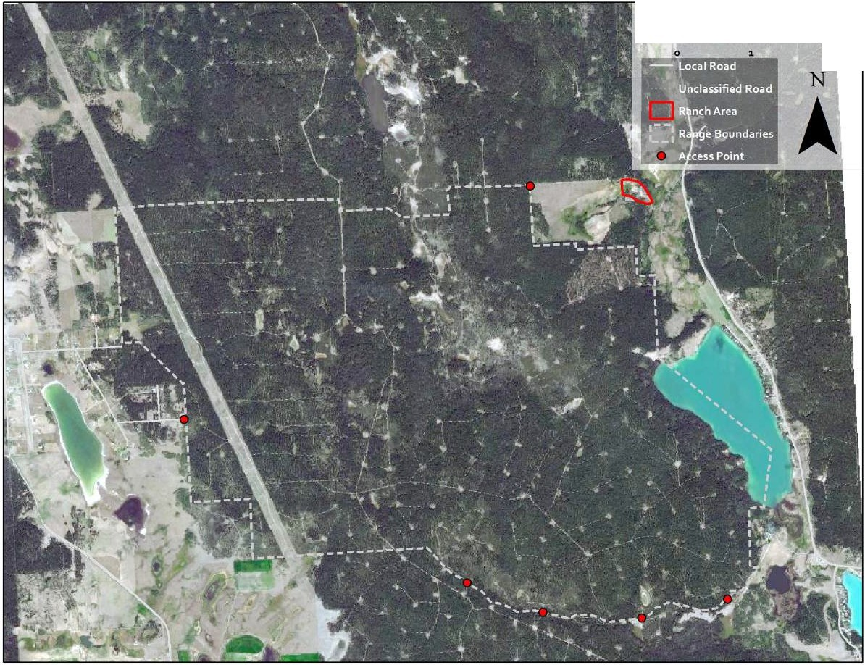

Sample Map: Sprinkler Setup Map

The Sprinkler Setup Map identifies water hook-up locations and includes a sprinkler setup plan to be used in case of emergency.
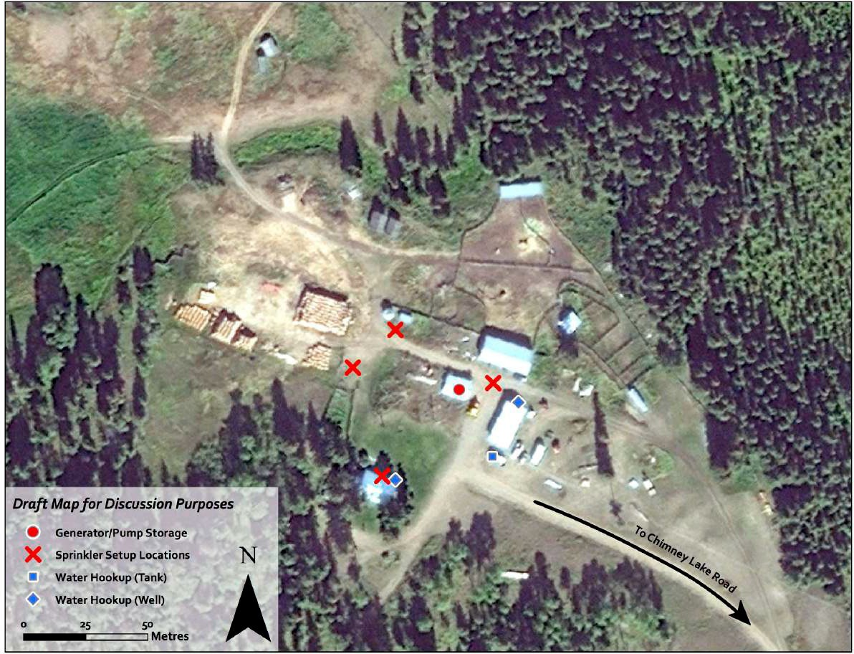

Sample Map: Contingency Plan
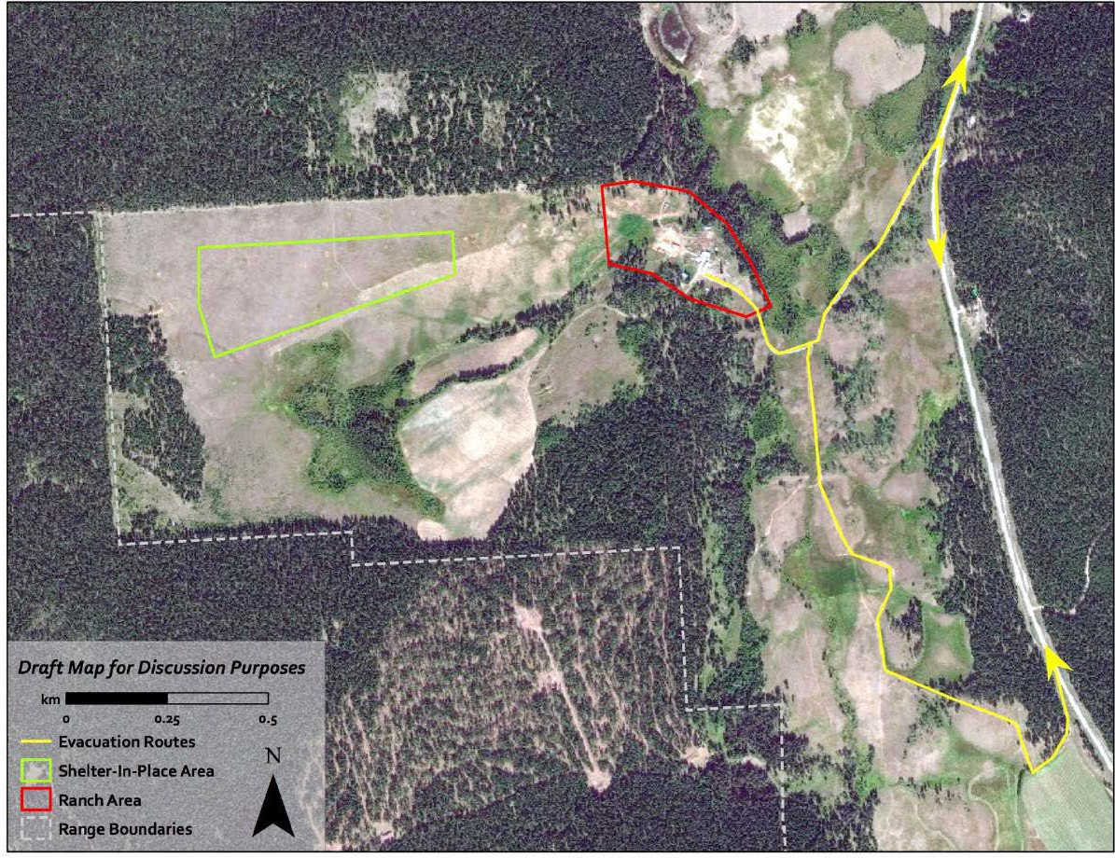

Livestock Inventory

[Skip to Section 8 if you do not have livestock on your property. If you have pets that need to be considered in wildfire planning, they may be listed in this section]

An up-to-date livestock inventory is especially important during wildfire. An inventory will help producers manage decisions during response, such as whether to shelter-in-place or to relocate livestock, and can be used to inform others who offer help.

It should also be noted that loss compensation through commercial insurance or other programs requires documentation of the animals on hand prior to impact.

Note: The operation may already have an inventory process that keeps the livestock information current and this may change frequently for some producers. Consider adding a copy of your existing records as an appendix to your Wildfire Plan.

Some producers or hobby farmers may have pets or non-farm business livestock they may wish to inventory for wildfire protection planning purposes. If this is the case, it is not necessary to complete

Section 15 - Decision Guide for Livestock Protection. Section 15 is intended primarily for use by commercial livestock producers.

If you do not have a current inventory, consider these steps in preparing one:
❑
❑

1. Identify the current number of animals on the property by type, using Section 6,
Livestock Inventory of the Workbook.
2. Prepare a list of animals by name, gender, and registration number, and attach the list to the Wildfire Plan.
3. Ensure all animal identification records are secured in a fire-resistant filing cabinet or at an off-site location, and that records will be available when needed.

Livestock Location(s)
If livestock are ranged at alternate locations during the wildfire season, including on the property and on a grazing lease, the expected livestock numbers by location will be valuable information for managing decisions during response, and for emergency responders in planning suppression operations on Crown Land.
❑

1. Identify the expected livestock numbers during the early and peak fire seasons by location (on property versus on Crown range tenure) as per usual turnout and roundup dates.

Vehicles and Response Equipment / Resources
Understanding the types of vehicles and special equipment that may be available in a wildfire emergency helps you plan for a successful response. This equipment may help producers respond to small wildfires, relocate livestock to safety, operate water pumps and electrical equipment, or perform other functions that would safeguard the operation.
A complete inventory of equipment is imperative for insurance purposes. Use the Workbook to identify functions for equipment in the event that some responders are not familiar with the equipment.
The Workbook includes space to record vehicles and equipment on the property and with close neighbours. This list may also help producers share equipment among their neighbours during a wildfire.

Account for available vehicles and response equipment by following these steps:
□

1. Using Section 8 of the Workbook, Vehicles and Response Equipment, include a list of personnel (including relevant certifications and training), livestock trailers, heavy equipment, and other equipment available from neighbours.
2. Discuss this list with neighbours to confirm the equipment and resources they may be able to share before, and during, wildfire.

Water Sources

Understanding the types of water sources that may be available for irrigation, sprinkler protection, and to support fire response, is important to safeguard the operation and activities essential to livestock and crop management during a wildfire. Examples of water sources include surface water (ponds, streams), private reservoirs (manual or powered gates), wells, water tanks, and stand pipes.

Many different water systems exist in the province. In some regions, water systems are centralized while in others, there may be independent water purveyors or authorities that are not integrated. In some circumstances, producers may be entirely self-sufficient for water supply. Water supply can be restricted and prioritized for use by response agencies during a wildfire event. Some water supply systems may also be vulnerable to power or internet outages or disruptions. Ensure you fully consider the water supply as well as the potential limitations and contact your water purveyor, if applicable. Prepare in advance and install cisterns or other water storage, as required. Cisterns may be filled with rainwater or wastewater and should be kept filled during wildfire season.

Account for water available for fire response by following these steps:

1. Use Section 9 of the Workbook, Water Sources, to include a list of water sources that are readily available on the property, or nearby, as a contingency, including both privately held and public resources that may potentially be accessed.
2. Discuss this list with neighbours and local water authorities or purveyors to confirm the availability of water sources before, and during, wildfire.

Risk Reduction – On Property
Producers can undertake many actions before a wildfire occurs to reduce the likelihood or impact of a wildfire on the property. It is important to understand how wildfire spread can impact agriculture operations, besides flame contact, such as:

  - Sparks or ember showers may travel 2 km or more in advance of a wildfire.
  - Radiant heat can ignite combustible or flammable materials, including structures or fuel storage, within 10 m, and potentially damage crops over an even greater distance.

10-1. Reduce Nearby Combustible Materials

Removing combustible vegetation and other materials around agriculture operation structures is one of the most effective ways of protecting the operation. Removing combustible materials around animal barns is especially important if the structure may be used to shelter livestock during a wildfire.

Consider risk to wooden power poles and gas and power lines which are often surrounded by grass fuels. Preventative measures include underground propane lines, aluminum sheeting around wooden poles to height of fuel, and regular clearing of grass fuels under and around wooden poles.

Reducing fuels is best done in advance of a fire so that the debris may be removed from the area

and disposed of safely. A large operation may benefit from a Wildfire Risk Assessment by a qualified expert. For more information on reducing combustible materials, see The Homeowners FireSmart Manual, at firesmartalberta.ca/at-home For additional resources, see the FireSmart Alberta website, at firesmartalberta.ca/

FireSmart uses the concept of priority zones, or FireSmart zones, to determine where and how hazard assessment should be conducted and what actions should be undertaken. The first three priority zones are as follows:
  - Priority Zone 1a: 0 - 1.5 m from the structure. Noncombustible material only.
  - Priority Zone 1: 1.5 - 10 m fuel-free, cleared zone around structures.
Priority Zone 2: 10 - 30 m out from structures, where most flammable vegetation is removed (i.e. fuels are reduced) to prevent ground fires spreading and moving up into the crowns of trees.

Check the actions below to take before a forest fire strikes:

1. Prepare an aerial photo or map of the agriculture operation and draw lines that are approximately 10 meters and 30 meters around all structures.
- Show on the map the combustible materials within 10 meters of structures that could be removed to reduce risks, including:
  - Trees and shrubs.
  - Packaging and pallets.
  - Pesticides or other hazardous material subject to volatilization and explosion.
  - Hay bales.
  - Woodpiles, deadfall.
  - Propane and other fuel tanks.
  - Other combustibles.
- In the area between 10 meters and 30 meters around each structure, identify on the map the combustibles that could be removed, such as:
  - Trees to increase spacing (e.g. conifers which are much more combustible than deciduous trees).
  - Low branches that could allow ground fire to spread to the canopy.
  - Deadfall.

- In the Workbook under 10-1 Reduce Combustible Materials, write down the actions that should be taken to remove combustible materials within 10 meters of structures, and between 10 meters to 30 meters. Options for reducing combustibles include:
  - Remove trees, bushes, and overhanging limbs within 10 m of buildings.
  - Thin trees to 3-6 m spacing.
  - Remove deadfall within 10 – 30 m of structures.
  - Clear vegetation from critical fence lines to 4 m.
  - Maintain 10 m fuel free buffer around corrals.
5. Dispose of cut vegetation safely, in compliance with local burning bylaws and approved disposal methods. Discuss with the local municipality any large-scale vegetation reduction efforts on the property to ensure you have the
proper permits.

10-2 Use Fire Resistant Materials

Producers can reduce risk by increasing the amount of fire-resistant building materials used.

Consider the following actions to improve fire resistant construction:
1. Identify the roof and siding materials on all structures. Pay attention to barns and other
structures that will be used for livestock shelter during a wildfire threat.
- In the Workbook under 10-2 Use Fire Resistant Materials, record the actions that would improve the fire resistance of the exposed building materials. Some options for fire resistant construction include:
  - Ensure buildings have metal, clay tile, or asphalt roofs.
  - Ensure buildings have non-flammable siding, such as metal or concrete.
  - Close or screen eaves and vents with 3 mm mesh.
  - Replace wooden fence posts with metal.

10-3. Plan for Sprinkler Protection
If the agriculture operation contains flexible irrigation systems, sprinklers may provide additional structure protection. Fire brands and burning branches can travel more than 2 kms ahead of a wildfire. Only having green fields or a wet fuel break on the landscape around structures may not provide enough protection. Sprinklers help create a wet environment around individual buildings. Sprinkler systems are particularly important where animals will be sheltered, such as pastures or barns. More information is available at southernirrigation.com/other-water-solutions/fire-suppression/

If sprinklers or hoses are limited, determine the priority of agriculture operation structures to protect ahead of time. Producers could put sprinkler equipment in place at the beginning of each fire season or leave the system permanently installed. More information is available at: southernirrigation.com/gate-catalogue/
Be informed of local water supply vulnerabilities (see Section 9, above) and prepare accordingly. Contingency water supply for sprinklers may include on-site water storage (cisterns are highly recommended), private water sources, and surface water, as available.

Consider the following actions to set up the sprinkler systems for protection of agriculture operations:
- Determine if existing sprinkler equipment is sufficient to create a humid envelope around all structures, or at least critical buildings, during wildfire.
❑

- Using Section 10-3, Sprinkler Protection in the Workbook, identify the priority of structures that should be protected by sprinklers.
- For more information on setting up structural sprinklers, refer to the wildfire preparedness videos in the additional resource section.
❑

- Determine if the primary water supply is vulnerable (check with the local water purveyor, if applicable) and have contingency water supply or storage (e.g., cisterns) in place for the sprinkler system. The volume of water required will depend on the size and number of buildings, surface area, and duration of sprinkling. It is recommended to engage a fire protection professional if you have a large facility or complex protection needs.

Risk Reduction – Range Level Assets

[Skip to Section 12 if you do not have livestock on Crown range tenure]

Producers can undertake actions in advance to protect critical assets on Crown range tenure that are at risk of damage by wildfire, or areas that may be important for emergency response. The primary action is fuel reduction, which requires careful consideration of the types and distribution of fuels, and an understanding of various treatment options, including disposal of the fuel, as well as associated maintenance requirements. In almost all cases, the advice of a qualified professional will be required to develop smart fuel reduction prescriptions, as described below. Actions may include,
the clearing of fuels from a fence right-of-way, or widening of the right-of-way, and maintaining fuel free buffers around corrals. Range assets may include:
  - Fencing.
  - Corrals.
  - Water developments (i.e. troughs).
  - Evacuation routes.
  - Safe spaces.
  - Loading areas.

There are opportunities for lease holders to cut trees in the vicinity of agricultural infrastructure, for fuel management purposes, under different regulations, such as the Forest and Range Practices Act and the Range Planning and Practices Regulation. However, any cutting of timber under any regulation requires a permit. Fuel management on Crown Land will generally require a detailed prescription to be developed by a qualified professional, to ensure that all regulatory and permit requirements are met.

For further information and prior to engaging in fuel management on Crown Land, consult with your local Resource Manager.

Check the actions below to take before a wildfire strikes:
❑

1. Identify areas critical to your day-to-day operations (e.g., corrals, loading areas) and fence lines that are most important to keeping your animals safe and on your range. Also identify areas that may be important for emergency response (e.g., safe spaces, evacuation routes).
2. Identify actions required to reduce fuels.

Insurance Information
Producers in Alberta have access to several approaches to insurance and managing financial losses due to the consequences of wildfire, as noted below. Refer to the specific links noted for detailed program information.

Private Insurance
Insurance plays an important role in protecting the agriculture producer from low-probability, high- consequence disasters, such as wildfires. Different types of private insurance are available to cover
losses to infrastructure (i.e. structures, fences, and equipment), crops, and livestock, as well business or income interruption losses due to wildfire.

Farm insurance coverage likely includes the cost of relocating livestock in an emergency, both during transportation and at relocation sites, depending on the specific policy. Insurers will likely reimburse producers for transportation and other costs incurred by actively protecting their animals. Some insurers cover fences. In some cases, special additional coverage is required for livestock and fencing. Check with your agent or broker for details of the specific infrastructure that is covered.

As an important step in managing risk, producers in Alberta should understand what is covered under their insurance policies and what may be excluded. For example, are your losses covered if livestock are harmed indirectly in a wildfire? Are both completed stock and crops in progress insured (i.e. harvested crops vs. crops in the ground)? Does completed stock such as hay and feed, need to be stored inside a structure to be covered by insurance? For horticulture and field crop producers, it is important to recognize how the different stages of production are covered under the insurance, from crops in the ground, to harvested, stored, processed, and transported product. Crop insurance is available commercially and through the government supported Alberta Production Insurance (see federal/provincial programs below). For some producers, business interruption or loss of profit insurance may be beneficial.

Be aware that your ability to purchase additional coverage, obtain a new insurance policy, or to renew your policy may be limited if your operation is located within a specified distance of active wildfire. It is advised that you renew your insurance outside of fire season, during the fall and winter, to ensure that you are not in an active fire situation at the time of renewal. Do not underestimate replacement costs relative to the cost of insurance, and communicate property improvements to your insurance broker as they occur to ensure they are covered. Talk with your insurance broker or agent at least annually, to ensure you have adequate insurance specific to your operation and location.
Comprehensive and consistent photo documentation of assets beforehand is recommended annually at insurance renewal, or when you prepare and update your Wildfire Plan. Photo documentation of your assets in their current state and condition, from the same location/position, before and after an event, will go a long way to expediting and supporting an insurance claim.

The Insurance Bureau of Canada can help producers find available coverage for business losses through private insurance programs. Its member companies represent approximately 90% of the property and casualty insurance market in Canada. Their website is www.ibc.ca/contact-us

Federal/Provincial Government Risk Management Programs
The federal and provincial governments provide a suite of cost-shared risk management programs for the agricultural sector that provide protection against different types of income and production losses applicable to crop and livestock producers. More information on these risk management programs are available at agriculture.canada.ca/en/programs/agriinsurance

Consider the following actions to ensure you have appropriate and adequate insurance and business risk management in place:
- Review all commercial insurance and government supported insurance or risk management programs relevant to your operations in the context of the following:
  - Local wildfire threat,
  - Potential direct and indirect impacts of wildfire to your assets, and
  - Anticipated realistic replacement costs and deductible limits.
- Meet with your insurance agent, broker, or program representative at least annually, to review your coverage, asking the following questions:
  - Is the potential loss of livestock covered if animals are moved from the farm to a safe location due to the threat of wildfire?
  - Are the costs of transportation, feed, water, and veterinary care for animals relocated during a wildfire emergency covered under the policy?
  - Does coverage include the costs of returning animals to the farm after the wildfire emergency has ended?
  - Does coverage include the costs of repairing fences and gates after damage due to wildfire?
  - Does the coverage include direct and indirect losses to crops, including yield, quality, and loss of stock?
  - Does coverage include loss of harvested, stored, processed, or transported crop products, as well as crops in the ground?
  - Does coverage include losses due to prolonged power outage due to a primary emergency, such as a wildfire?
  - What infrastructure relevant to my operations is covered?
  - What steps should be taken when damage occurs?
Record the answers in the space provided for Key Coverages and Exclusions in Section 12 of the Wildfire Plan.
3. Ensure you understand your policy and are aware of what is included and what is excluded.

Backup Power
Agriculture operations likely depend on electrical equipment that could be vulnerable to power interruption. Wildfires have the potential to trigger prolonged power outages locally and throughout the region. It is therefore wise for producers to anticipate prolonged outages and to take steps before disaster strikes to protect critical systems.

Essential agriculture operation systems requiring electrical power may include:
  - Irrigation.
  - Refrigeration equipment.
  - Processing systems.
  - Dairy milking systems.
  - Feeding systems.
  - Water pumps.
  - Sewer system.
  - Freezers.

These actions are needed to set up the backup power systems for agriculture operation equipment:

1. Identify the available backup power supply equipment that could be used in a prolonged power outage.
2. Use the Workbook Section 13, Backup Power to identify the priorities for agriculture equipment that should be supported by backup power systems.

Note: Protect yourself and the community around you by ensuring that any generator backup systems are properly installed to ensure no back-feed into the power grid. Electrical systems must be wired to exclude regular electric power.

Part B: During a Wildfire

Information Sources
One of the first steps in any emergency is to learn as much about the situation as possible, from a credible source. In wildfire emergencies, local governments work closely with the Alberta Wildfire Service to contain and control wildfires, but fire behavior can change rapidly. Factors that influence wildfires include winds, humidity, temperature, the types of vegetation being burned, and the slope of the land.

If a major wildfire threatens populated areas, the local government will consider issuing notices:

Evacuation Alert – Under an Evacuation Alert, people have time to collect their family members and personal items, and to prepare to move to a safe area.
Producers may also have enough time to protect their agriculture operation and livestock. Some wildfires advance quickly and will not allow time for an Evacuation Alert.
Evacuation Order – If an Evacuation Order is issued, everyone must leave immediately. Producers may be able to leave livestock to shelter in barns or move them to open fields. The important thing is to quickly get everyone to safety. In some cases, producers may be allowed to return to their property for short periods to perform essential livestock and crop management services including attending to their animals, although this is not guaranteed.
Evacuation Rescind – A Rescind is issued when the Incident Commander determines it is safe for residents and livestock to return home. The local government will provide information to returning residents on potential hazards and safety precautions.

The status of the Evacuation will be communicated via the local news media, perhaps through an evacuation notification team, and the local government website. Social media may also be staffed and utilized, when available. It is important to follow instructions and evacuate when ordered to do so. Life and safety are top priority and emergency responders will not be allowed to endanger their lives to rescue anyone who does not evacuate.

This section of the Wildfire Plan includes contact information for the current sources of information, including local media and Alberta Wildfire.

Use these steps to customize the Workbook for your information and authority sources (local and provincial) to ensure you will be able to stay up to date on the wildfire situation:
□
❑

1. Use Section 14, Information Sources in the Workbook to confirm the news and authority sources to consult during a wildfire.
2. Check with your County or Municipal District office for any emergency notification systems currently in place, and register if available.

Decision Guide for Livestock Protection

[Skip to Section 20 if you do not have livestock on your property]

The calm period before disaster strikes is a good time to explore some options for protecting livestock from wildfire. Consider these four options in selecting the best way to protect your animals:
Option 1 - Shelter Livestock in Barn: This option means keeping animals in a structure on the farm or operation, such as a barn, where they will be protected while personnel evacuate. This may be the best option if FireSmart measures, sprinklers,
and other protections are in place at the time of the emergency.

Option 2 - Move Livestock to an On-site, Outdoor Location: Under this alternative, some, or all, animals would be moved to a pasture, open field, or other outdoor area that would provide protection from the threat.

Option 3 - Relocate Livestock Off Site. Relocating livestock means moving them off of the farm or operation and away from danger. In a situation where a wildfire threatens a large area, this may require moving animals out of the region.

There are risks with all the above options, but the producer should select the approach with the greatest chance of success for their operation, all things considered.

Section 15, Decision Guide for Livestock Protection of the Workbook should be used when a wildfire emergency presents itself. Producers may wish to adopt a different option for each type of animal. For example, cows may be allowed to shelter in barn while horses are relocated.

Take these actions to ensure the Wildfire Plan reflects the available options for livestock protection:
□

1. Using Section 15 of the Workbook, Decision Guide, confirm the options that are available for livestock protection during a wildfire emergency.

2. Refer to Sections 16, 17, 18 and 19 of the Workbook to help determine viable alternatives for livestock protection.

Checklist for Sheltering Livestock in Barn
Sheltering animals in a barn means moving or confining the animals to a protected structure on the farm. This is a particularly important option for dairy herds and large poultry flocks that are difficult to relocate. Considering a wildfire threat, a protected barn or shed is one that has:
  - Reduced combustible materials approximately 10 m from farm structures.
  - Fire resistant materials.
  - Sprinkler protection, with suitable water pumps and backup power.
Consider these actions to confirm that sheltering-in-barn would protect livestock:

1. Determine if there is a structure or site on the farm where animals will be protected from the wildfire.
2. Determine if animals that are sheltered in place will have access to food sources, water, and ample living space. An Evacuation Order may be in place for many days, and producers may not be allowed to return even temporarily to tend to animals due to extreme risks.
3. Identify any actions in Section 16 of the Wildfire Plan that are needed in an emergency to shelter livestock in a barn.
4. Show on the map for the Wildfire Plan any structures that may be used for sheltering livestock.

Checklist for Moving Livestock to On-Site, Outdoor Location
□
□
Depending on the farm layout, there may be an outdoor location where animals can escape the threat. Such protected areas may include a pasture that can be wetted with sprinklers, a heavily grazed area, or a plowed field.

An outdoor area used to shelter animals should be:
  - At least 0.5 ha (1 acre) in size.
  - At least 100 m from nearest timber.
  - Free of combustible fuels - mowed, grazed to stubble, plowed, or irrigated.
  - Free of barbed-wire fencing.
  - Free of overhead powerlines or other falling hazards.
  - Have enough water and feed for at least 3 days.
  - Have more than one route in and out.

Confirm that moving animals to an open field would provide protection:

1. Determine if there is a site on the farm where animals can be moved to protect them from a wildfire.
2. Determine if the animals will have access to food sources, water, and ample living space.
3. Record the actions in Section 17 of the Wildfire Plan that must be followed to move animals to an open area.
4. Show on the map for the Wildfire Plan all locations that may provide protection for outdoor animals

Checklist for Relocating Livestock
Relocating animals off the farm may be appropriate, depending on the characteristics of the wildfire, the level of preparedness, the type of animal, and the time available.

Identifying a ‘buddy farm’ ahead of time is one of the most important steps in preparing for livestock relocation. A buddy farm is one that has agreed to receive and care for animals from the threatened property. Arranging for the trucks, trailers, drivers, and handlers needed to transport animals is also important to complete before an emergency strikes.

Note: The Evacuation Alert phase is the preferred time for relocating livestock, if time is available. During an Evacuation Order, the RCMP will strictly enforce traffic flows that prioritize the movement of residents to safety and will only allow livestock movement if it does not interfere with the movement of people and emergency operations.

If relocating livestock is a potential option, complete the following actions:

1. Determine which animals are suitable for relocation, considering loading time requirements for different species. Record which animals should have priority for relocation in case time is short, using Section 18, Checklist for Relocating Livestock.
2. Locate and prearrange one or more off-farm sites, including buddy farms, for the livestock. Include the name, address, and contact information for each location in the Wildfire Plan.

When identifying a buddy farm, it is important that they are located in a different area not likely to be impacted by the same wildfire. To avoid confusion and misunderstanding, arrangements may be agreed to and documented in a Mutual Aid Agreement or Memorandum of Understanding. Considerations include channels of communication, extent and type of assistance to be provided, who will bear costs incurred, and an annual site visit and review of emergency plans, animal inventory, and biosecurity requirements. ALERT (see Part E, Resources) provides supports and tools to assist in pre-planning.
3. Select a method for quickly identifying farm animals that do not already have ear tags, brands, or other identifying marks. Some ‘just-in-time’ methods include paint on hooves and collaring.
4. Determine transport equipment required to move selected animals, appropriate loading facilities, and ability to maneuver haulers in and around the farm.
5. Indicate on the Agriculture Operation Map the locations for loading the different types of animals.
6. If possible, identify the individuals or organizations that can haul the livestock to the off- property relocation sites, and turnaround times for multiple trips. Use Section 18, Checklist for Relocating Livestock to record hauler contact information.
7. For each animal type, list the special feed, water, medications, and care that should be available at the relocation site. Indicate who will provide for these items.
8. Recognize special planning requirements for relocating certain livestock, especially poultry and milking herds, such as buddy farm locations, milking capacity, and transport challenges. Be aware of biosecurity and disease control requirements for relocating your animals to the selected off-farm site and ensure complete documentation of required vaccinations.
9. If government funded assistance will be required on an event specific basis, check with the local government Emergency Management and/or Ministry of Agriculture for current policy and procedures regarding pre-approval requirements prior to evacuation: www.alberta.ca/farm-animals-and-livestock-preparedness

Note: During emergencies, the primary responsibility for livestock protection lies with the individual producer and if they have the ability to relocate livestock themselves, they are encouraged to do so. However, response costs incurred directly by the producer are not eligible for reimbursement.

Alberta Government support for livestock relocation generally targets only commercial producers. Non-farm business livestock owners or producers with pets may obtain support from the Alberta SPCA
www.albertaspca.org/

If relocating livestock during a wildfire is not possible, animals may still be adequately safeguarded by protecting structures ahead of time (e.g. FireSmart milking parlors).

Checklist for Opening Gates, Cutting Fences to Free Animals
In some situations, such as rapid wildfire spread, the best thing may be to free the animals to green space or pasture. Animals will most often seek safety if unconfined. The Wildfire Plan should identify if it is safe to free your animals and how to do so, such as where to open gates and cut fences that direct animals away from roadways and populated areas.

Freeing animals may present risks to people nearby. The degree of risk depends on the location of the released livestock and the proximity to busy roadways and routes that may be used for the evacuation of people. Carefully evaluate these risks when considering the opening of gates and cutting of fences in a wildfire emergency, as you may be held responsible for damage caused by animals that are released. The key thing to remember is what would a reasonable and prudent person do with your experience and knowledge.

Note: Emergency response crews should be informed if any large animals are freed, such as cattle and horses. They may be able to help protect the animals and other people from harm.

If freeing animals is a suitable option, consider the following actions:
❑
❑

1. Determine which gates should be opened and indicate them on the Agriculture Operation Map.
2. Identify where fences may be cut or opened to allow animals to escape to pasture. Show these locations on the Agriculture Operation Map.

Checklist to Create a Fire Break
If time allows, agriculture operations will gain additional protection from fire breaks that impede the spread of ground-based fire. For example, using a tractor and plow implement producers can create a reduced-vegetation strip around the perimeter of the operation or around structures. Be aware of underground service lines.

Consider the following actions to help with creating a fire break when needed:
□
❑

1. Review the checklist in Workbook Section 20, Checklist to Create a Fire Break, to
ensure it describes the areas to be plowed.
2. Prepare a rough sketch of the areas to be plowed to provide fire breaks.

Checklist to Deploy Sprinklers

If sprinkler deployment is possible (refer to Section 10-3), there are a few steps to take in advance to ensure the Wildfire Plan provides the proper guidance during a wildfire.

Consider the following actions to ensure the Plan assists with sprinkler activation:
□

1. Review the checklist in Workbook Section 21, Checklist to Deploy Sprinklers, to ensure it includes all steps needed to quickly set the system in operation.
2. The best instructions are ones that have been tested. Take the time to set out the selected sprinkler systems and record the steps as if instructing someone who has
offered to help.

Checklist for Operating Backup Generator
If alternate power systems are available on the property, prepare the instructions in Section 22 of the Wildfire Plan to allow them to be set up and activated quickly.

Take these actions to include the proper instructions for operating backup generators:
□
❑

1. Review the checklist in Workbook Section 22, Checklist for Operating Backup Generator, to ensure it includes all steps needed for quick operation.
2. Test the instructions and ensure all the equipment can be easily located.
3. Ensure that grid-based electric systems are disengaged when the backup generator system is operational.

Checklist for Personal Evacuation
When the local government or Province issues an Evacuation Order, all persons must leave the defined area. Road access to the evacuated area will be secured and you will not be allowed to return without a permit. The Wildfire Plan should anticipate how separated family members and staff can check-in with each other once they have dispersed.
Evacuated persons are encouraged to register at a local Reception Centre, even if they do not need assistance. This can assist with family reunification, emergency care, and current emergency information.
Use Section 23, Checklist for Personal Evacuation to prepare a checklist of actions that should be taken before leaving the operation.

Consider the following actions to prepare for personal evacuation:
□
❑

1. Consult the Workbook for the contents of a home Grab ‘n’ Go Kit. Make a list and assemble the items. Keep this kit in a vehicle or other location for ease of access, availability.
- In addition to the kit, prepare a list of operation and farm-related items that should be taken. Add these items to Section 23 of the Workbook, Checklist for Personal
Evacuation. Such items may include:
  - Handling equipment, such as halters.
  - Cages.
  - Blankets.
  - Appropriate tools for each kind of animal.
  - Building keys, critical documentation.
  - Employee records.

❑ | 3. Identify a single person outside the region that members of the family and staff can contact if they are separated during the evacuation.

Checklist for Visitor and Employee Evacuation

[Skip to Part C if you do not receive visitors / tourists or do not have employees on your property that would be at risk during wildfire season]

Visitor evacuation will primarily be a concern for agri-tourism operations or other agricultural operations that receive a significant number of visitors at any time during wildfire season. This may be applicable to operations with on-site wineries, restaurants, U-pick, on-site tours, accommodation, and farm gate or other retail sales.
Employee evacuation is an important consideration for all operations, but is of particular importance for agriculture operations with large numbers of full-time or seasonal employees on site during the wildfire season. In some cases, these employees may also be residing on site.
If you employ out-of-province personnel, provide documentation to confirm their employment at your operation in order for them to be eligible to receive assistance from Emergency Social Services at evacuation reception centers. Keeping an employee list and employee identification records centralized and ready to grab and go is recommended.
- Determine key roles and responsibilities for implementing the evacuation plan. This includes the primary and backup decision-makers and coordinators, and roles for other participants appropriate to your operations. Ensure that contact information for designated individuals is included in Section 4, Emergency Contacts. The decision maker or coordinator responsibilities will generally include the following:
  - Review and update the Evacuation Checklist annually.
  - Ensure all emergency evacuation roles are assigned and participants are informed and aware of their responsibilities.
  - Determine when or if to pre-emptively limit visitor access.
  - Initiate and coordinate evacuation.
 | 2. Determine who to communicate with to keep employees and visitors informed during wildfire emergencies, as well as what information is required to be communicated and who is responsible. This will include monitoring relevant and reliable sources of information (see Section 14) to keep informed of latest developments with respect to local or nearby wildfire activity and threat, and evacuation alerts or orders to aid in decision making. The Tourism Industry Association of Alberta and Destination Alberta may have resources, updates, and links to share with visitors and to inform yourself (see Part E – Resources).
❑ | - Identify any barriers to effective communication and develop appropriate modes and methods of communication:  - In the event of limited mobile phone reception, consider handheld satellite communications devices with 2-way text communication capability, such as inReach www.garmin.com/en-CA/p/793265  - In the event of language barriers, such as between owner/operators, employees, and visitors with no English or English as a second language, create a user-friendly copy of the evacuation plan with visuals, such as a map, clear instructions, and translation of essential information, as required. (Translation services may be available from the local Immigrant Services Society).
 | 4. Identify routes and exits from your operation, considering all buildings and business sites where visitors and employees may be located at any given time. Buildings or locations for visitors may include wine cellars, tasting rooms, restaurants, picnic areas, parking lots, in-field tours, in-field picking etc. Identify any egress constraints (single exit or egress road) and special procedures required to limit congestion and ensure safe exit, such as a pilot car and tag car process. Orderly exit and minimizing traffic jams is critical. Identify any challenging aspects such as locating and evacuating visitors and employees that are dispersed over a large site, such as U-pick operations and orchards or vineyards. Make note of all roads, trails, and gate locations. Consider designating a marshalling point before evacuating the property.
 | 5. Identify a post-evacuation assembly area, recognizing that this may be subject to change if your designated assembly area is inside the evacuation zone (i.e. emergency center or designated safe zone, such as a school ground or open public space safe from fire).
6. Develop a system for accounting for personnel and visitors which includes designating an individual or individuals responsible. The most effective system will depend on the size and complexity of your operation. Options include visitor and employee contact lists, as applicable. In some operations it may be difficult to control and track people coming and going. As a precautionary measure, consider limiting entry to parts of the property during the alert stage. Recognize that alerts may, however, be in place for weeks.
Conduct a final property sweep at the time of evacuation to ensure no visitors or employees are missing.

7. Confirm emergency shut-off procedures for utilities, equipment, and processes as applicable. Know where your electrical panel and gas and water shut-off valves are located, and how to turn them off.
Note: Only a registered contractor can safely turn gas back on. Similarly, know the locations and shut-off procedures for any equipment or processes to be shut down before evacuating.
 | 8. Confirm procedures for assisting visitors and employees with disabilities or mobility issues.
9. Ensure designated employees are aware of the evacuation procedures and routes, and that these can be effectively communicated to visitors during an evacuation.

It is recommended that a mock evacuation be conducted annually or periodically, subject to staff changeover and experience.

Wildfire evacuation training and hazard awareness for employees can be integrated into your regular worksite safety program, such as employee orientations, safety meetings, and training. Simplified, user-friendly versions of the evacuation plan may be distributed to employees at the time of orientation.

During an Evacuation:

- Follow instructions provided by emergency officials. These may be delivered via websites, social media, notifications to site etc.
❑

- Complete emergency shut-off procedures for utilities, equipment, and processes.
❑

- Take your individual Grab ‘n’ Go Kits and any critical paperwork. Keep copies of important records in a waterproof, fireproof, and portable container.
❑
open.alberta.ca/publications/emergency-kit-checklist
- Assist individuals with mobility issues or disabilities.

- Account for personnel and visitors after evacuating, including a final sweep of the property.

After Evacuation:

Once the Evacuation Order is rescinded, emergency officials from the local government or Province will advise when it is safe to return and if there are any special considerations to ensure the safety of visitors and staff at your operation.

Part C: After a Wildfire

Checklist for Damage Assessment
Once the danger has passed in an emergency, the local government or Province will rescind an Evacuation Order and allow residents to return to their homes and agriculture operations.

If the operation has suffered any damage, there are several actions that can be taken to reduce the impact and to speed recovery. This section of the Wildfire Plan contains reminders of things to do after an emergency.

The following steps will help clarify the actions to take in assessing damage after a wildfire event:

1. Consider the checklist shown in Section 25 of the Workbook, Checklist for Damage Assessment, and make any revisions that would better suit your operation.
□

Checklist for Initiating Insurance or Other Loss Coverage

Major wildfire emergencies may have catastrophic consequences for an individual agriculture operation. Some damage may be unavoidable, regardless of the level of preparedness.

Producers in Alberta have access to several approaches to managing these financial losses, as previously noted in Section 12 and as noted below. These include:

Commercial Insurance
see Section 12 of this Guide

Federal/Provincial Government Risk Management Programs
These include insurance and income protection programs as noted in Section 12. Currently, producers have access to a comprehensive suite of Business Risk Management (BRM) programs, including AgriStability, AgriInsurance, and AgriInvest that are the first line of defence when facing disasters. Funding may be available for losses incurred during a declared disaster and not covered by other programs, and may be
cost-shared between the Provincial and Federal governments. More information on this risk management program is available at:
www.alberta.ca/disaster-assistance-and-recovery-support
Note: Government programs are subject to review and change. Check with your local Ministry of Agriculture contact for the current program, see contact information in Workbook Section 4.

Provincial Disaster Financial Assistance
Financial assistance is available to help when facing uninsurable loss after a disaster.
The Provincial Recovery Framework provides a foundation to build and strengthen our ability to coordinate provincial resources during recovery. It outlines existing approaches to create a consistent and effective provincial approach.
The Disaster Recovery Program and Municipal Wildfire Assistance Program are intended to assist with widespread disaster events. Disaster financial assistance may be accessed after a municipality applies and is approved for a Disaster Recovery Program on behalf of their residents. Once a program is created, residents and other applicants may then apply for financial assistance. A state of local emergency does not have to be declared in order to receive financial assistance under a Disaster Recovery Program
www.alberta.ca/disaster-assistance-and-recovery-support

Wildfire Service Fire Suppression Disturbance Rehabilitation
Sites impacted by fire suppression activities are required to be rehabilitated to ensure that the natural drainage patterns are maintained and fuel hazards are minimized. This includes mitigation of impacts to land features (e.g. watering holes, pastures) on private land. Producers may also be eligible for compensation for loss or damage to structures, such as buildings, fencing, and waterlines damaged as a direct result of fire suppression activities on private property. Contact the local County office for information, see contact information in Workbook Section 4.

Some disaster relief programs are time-restricted and the funds available may be limited. Initiate a claim for assistance as soon as possible and within the program-specific application time limits, following declared completion of the wildfire event.
Insurance, provincial risk management programs, and disaster financial assistance represent the last lines of disaster defense. Insurers and governments at all levels expect producers to take reasonable steps to protect their operations and livestock and to not rely only on disaster recovery programs.
Risk reduction efforts, combined with a Wildfire Plan and insurance, provide the breadth of protection needed by producers and livestock owners.

Use the following steps to initiate insurance and other loss coverage.
❑

1. Review the basic insurance information for the agriculture operation in Section 12,
Insurance Information.
2. Contact insurance agent, or government program agent if you have paid into or subscribed to a business risk management program, to report the damage. Refer to the Guide Section 12, Insurance Information).

Remember that an insurance broker is your advisor and can explain things. On the other hand, an insurance adjuster works for the insurance company and is there to determine if, and to what degree, you are covered for damages they can verify. It is an important distinction to help you to direct your questions to the right individual.

3. Complete a thorough damage assessment, as per the Workbook and Section 25 of this
□
Guide, keep accurate records, including notes, receipts, and photographs, and document the value of lost assets. Assemble all required supporting documentation and complete and submit claims for losses. Do not rush to settle an insurance claim; be aware that the real damage may not be apparent right away.

Checklist for Recovery
Recovering from a disaster, such as a wildfire, may take months, or even years. Much depends on the extent of damage and the degree of collaboration that draws the community together. Disaster Recovery Planning support is available through the Disaster Recovery Program www.alberta.ca/disaster-recovery-programs

Following a significant disaster, municipalities will continue to share information and coordinate resources within the region.

Follow these steps to consider the disaster recovery phase of a wildfire event, and the potential actions for the operation:
□
❑

1. Review the actions in Section 27 of the Workbook, Checklist for Recovery, and make any amendments and additions that suit the operation.
2. Speak with members of the farmer institutes and agriculture associations that support your agriculture commodity group within the region, and enquire about their ability to assist in disaster recovery.
3. If your operation is damaged, consider reconstruction in ways that protects livestock and operations from future threats, such as including combustion resistant building
materials for structures and fences.

Part D: When Wildfire Plan is Complete
- Finalizing, Storing, and Sharing the Wildfire Plan and Summary

Once all the steps are completed in preparing the Wildfire Plan, it is time to make sure the plan is available and will be used as designed.
Consider these steps in finalizing the Wildfire Plan:
❑
❑
❑
❑

1. Make sure all the critical elements of agriculture operation information, including maps and response plans, are included in the Wildfire Plan, both in the electronic file and
a master physical copy.
2. Finalize the Table of Contents for the Wildfire Plan. Click on the Table and then on the tab ‘Update Table’.
3. Make multiple copies of the Wildfire Plan, and store copies in different locations around operation buildings, with one copy in a personal vehicle. Also, add an electronic copy to an off-site location, such as with a family member or in Canadian cloud storage.
4. Ensure that all family members and personnel understand the contents of the Wildfire Plan and know where to find it. Talk it over with them so that all understand the steps needed to protect the operation from a major wildfire emergency.
5. Complete the separate Wildfire Plan Summary (Appendix A of the Workbook) The Wildfire Plan Summary may be used to initiate dialogue with key agencies , such as the regional district, fire departments, or Alberta Wildfire Service, in advance of the wildfire season, and may assist to support identification and protection of your operation.

Because agriculture operations and contacts are likely to change over time, it is important to review and update the Wildfire Plan at least once each year. Revisit each section of this Guide to confirm essential information and your choices.

Part E: Additional Resources
The Workbook and Guide complement other wildfire and emergency guidelines, reports, and documents that may be of interest, accessed through the websites shown here.

Animal Lifeline Emergency Response Team (ALERT) – A volunteer-based organization that provides emergency services for domestic animals and livestock in a disaster. Volunteers also support neighborhood pre-planning and development of response kits, mutual aid agreements and other training and resources.
alertcanada.org/ | 250-809-7152 | informationofficer@alertcanada.org

Saddle Hills County – Administers tax assessments for all private properties in the County, which are identified by Land Title PID and Folio Number.

The Roll Number is a number assigned to private property for assessment administrative purposes, normally printed in the top right corner of an Assessment Notice. For most assessments, one roll number is used for each specific property. It is possible that one property is comprised of several roll numbers, or one roll number can cover several properties. This number may also be as a spatial link to local government or regional district mapping.

Premises Identification (PID), one of the pillars of traceability, links livestock and poultry to land locations or premises. It is also used as an early warning system to notify animal owners of a natural disaster such as a flood or fire that could affect their animals.

partners.agric.gov.ab.ca/pid/welcome.page

Alberta Emergency Preparedness Tips – The Government of Alberta offers an online guide on emergency preparedness for livestock and crop producers

www.alberta.ca/emergency-preparedness
Alberta Environmental Farm Plan – The Environmental Farm Plan (EFP) is an opportunity to assess areas of strength and potential environmental risks on your farming operation. It provides you with increased awareness of areas of potential environmental concern and helps outline site-specific, individualized plans to address, monitor or compensate for these risks.
www.albertaefp.com
AFSC Crop Insurance – Agriculture Financial Services (AFSC) provides crop insurance for annual and perennial crops. Production insurance covers crop losses due to wildfire including yield, quality and crop loss. A wide range of crops are insurable.
afsc.ca/crop-insurance/annual-crop-insurance-2024

Alberta Wildfire Status Dashboard – This website offers information about fire bans and current wildfire threats.
www.arcgis.com/apps/dashboards/3ffcc2d0ef3e4e0999b0cf8b636defa3
AgriRecovery – AgriRecovery is an FPT disaster relief framework intended to work together with the core Business Risk Management (BRM) programs to help agricultural producers recover from natural disasters. The core BRM programs are, in part, designed to help producers deal with the income and production losses they experience when disasters occur.
agriculture.canada.ca/en/programs/agrirecovery
Emergency Management Guidebooks for Producers – The Alberta Ministry of Agriculture has prepared three emergency management guides for specific commodity groups and one for small mixed farms.
Beef - animalhealth.ca/wp-content/uploads/2020/01/AHEM-ABP-Handbook_DIGITAL.pdf
Dairy – animalhealth.ca/wp-content/uploads/2020/01/AHEM_ABMilk_Handbook-DIGITAL.pdf
Pork - animalhealth.ca/wp-content/uploads/2020/08/AHEM_AB_Pork_Handbook.pdf
Small Mixed Farms - animalhealth.ca/ahem/resources/

Alberta Farm Fuel Benefit – The Alberta Farm Fuel Benefit (AFFB) Program allows eligible producers to receive a 9 cent per litre provincial fuel tax exemption on the purchase of dyed gasoline and diesel.
www.alberta.ca/farm-fuel-and-rural-utility-programs
FireSmart AB – This website offers extensive information on the FireSmart program.
A great online resource for Albertans.
firesmartalberta.ca/
In the Woods Animal Rescue – This Nampa, AB based Animal Rescue is able to take in Livestock. Contact Sheryl 780-618-6603, or Cheryl B 780-780-523-7525.
www.inthewoodsrescue.com/
Livestock Relocation – This Ministry of Agriculture and Irrigation site provides an overview of provincial supports for livestock relocation, including relevant policy, procedures and application for relocation assistance, as well as resources for non-farm business livestock owners
www.alberta.ca/farm-animals-and-livestock-preparedness

Alberta Veterinary Medical Association Livestock Relocation During an Emergency Factsheet – This two-page guide lists specific actions to take when considering livestock relocation.
www.albertaanimalhealthsource.ca/content/livestock-emergency-preparedness
Premises ID – The Alberta Premises ID program links livestock and poultry to geographic locations and allows for rapid notification of livestock and poultry producers during emergencies. The Program was established to reduce the impact of livestock disease or natural disaster by gathering and organizing information about the location of animals, the types of animals at each location, and how to contact those responsible for the health of those animals quickly. Registration is not mandatory and is applicable to producers that raise livestock or poultry, or transport them to and from the premises. A premises is a parcel of land where animals, plants, or food are grown, kept, assembled, or disposed of, and includes farms, stables, hobby farms, pastures, and other places. For further information on the Program, eligibility and to register (online registration and paper form options), visit the following website
partners.agric.gov.ab.ca/pid/
www.alberta.ca/system/files/custom_downloaded_images/af-albertas-livestock-and-poultry-traceability.pdf
Workbook Agriculture Appendix for Alberta Local Authority Emergency Plans – This Plan contains guiding policies, procedures and forms for local authorities coordinating agriculture emergency relocation support. Page 10 has a comprehensive list of agriculture associations and contacts.
Sources for Sprinkler Systems
Flash Fire & Safety: www.flashfiresafety.com/structural-protection
Spiedr: www.spiedr.com/sprinkler-kits/deluge-1-protects-4-structures
Wholesale Fire & Rescue (WFR): www.wfrfire.com/shop
Water Winger: waterwinger.ca/product-category/structure-protection-packages
Amazon.ca:www.amazon.ca/s?k=structure+protection+sprinklers&crid=X4QLSPLS7AT5&sprefix=structure+protection+sprinkler%2Caps%2C150&ref=nb_sb_noss
Peavy Mart: www.peaveymart.com/lawn-garden/watering/sprinklers/brass-tripod-sprinkler-3-4-/3521685?srsltid=AfmBOopSRcItykcYsSSEsgPNWYfzwN2tC-etUUkWRUu331QBfVm0pcMFnh4
Southern Irrigation: southernirrigation.com/gate-catalogue/
Fire Preparedness videos.
Refer to links below for additional Firesafe procedures.

How to FireSmart Your Home: www.youtube.com/watch?v=1VZWwC0PhUk
Protect Your Home from Wildfire – Top 3 Tips: www.youtube.com/watch?v=0zaHTk5NEDU
Some Steps to Protect Your Home From Wildfires: www.youtube.com/watch?v=YMzzzl_sBiI
Using Roof top sprinklers: www.youtube.com/watch?v=zWPeKSepma0
How to Build Your Own Water Trailer for Irrigation, Farming, Fire Fighting, Home use: www.youtube.com/watch?v=1EI7fX_PGJc

